Title: International Trade Theory
Subject: EEP 4

1. The Model for small country  A. Free Trade  B. Protectionism  a. Tariffs  b. Quotas  c. NTBs  C. Why is world demand inelastic?  2. The model for large country  A. Large countries equilibrium  B. Effects of a Tariff  Appendix | Assumptions: Homogenous goods, perfect competition, no transport costs, no ecnoomimies of scale  Key: Small country hypothesis = World supply Sw perfectly elastic  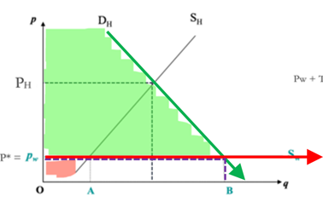  A. Free Trade  Free Trade: We are importing AB, we are producing OA, we are consuming OB.  *Sh < Sw onluy for a small portion, Foreigners are more efficient than us!  B. Protectionsim  TARIFFS  Ad valorem: T_{H} = P_{W}(1+t), ex. Pw = 40, we apply a tariff t = 20% => T_{H} = 40 (1 + 0.2) = 48  Specific: T_{H} = P_{W} + T, ex. Pw = 40, we apply a tariff t = 8 => T_{H} = 40 + 8 = 48  Two outcomes:  Prohibitive tariff: leads to autarky. Tariff st Pw+T = P_{H} = P*  Non prohibitive tariff: T_{H} < P_{H}  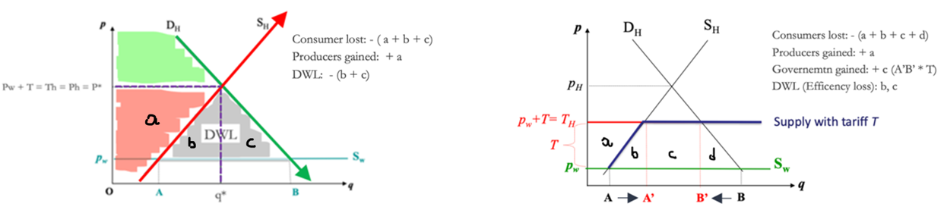  *See appendix for numerical example  QUOTA  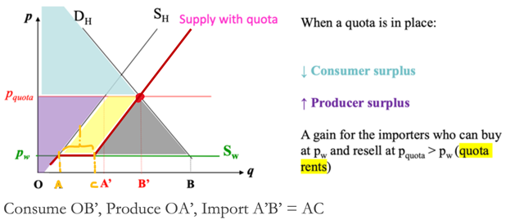  Idea: An import quota is a quantitative restriction on the amount of some good that may be imported  Model: You can import just the first amount AC (follow world supply just on AC), then you have to follow your domestic supply  With Quota = 0 there is autarky  *Quota Rents: Gov limits the quantity of a particular good that can be imported into a country. The Gov issues licenses to certain firms authorizing them to import a specified amount of the restricted goods.  Comparison: Tariffs vs Quotas => For every quota there is an equivalent tariff: T must be set = P_{QUOTA} - P_{W}  BUT with tariffs, the government gets tariff revenues, with quotas no (this is way quotas are not popular)  Non-Tariff Barriers (NTBs): Set of rules that each country imposes to regulate industrial production methods. Ex:  a. Sanitary requirements:  i. Restriction of dangerous substances (ex. EU meat treated with certain hormones and of chlorine-washed chicken (ex. KFC).  ii. Measures for preventing dissemination of disease. Tools: certifications, testing and inspection.  b. Technical requirements:  Need of certain standads, technical features and quality requirements (e.g. to flammability). Ex. This Kinder Surprise egg is banned in the US  Note: You can impose restrictions on other eu contries only if there is a clear danger for your consumers  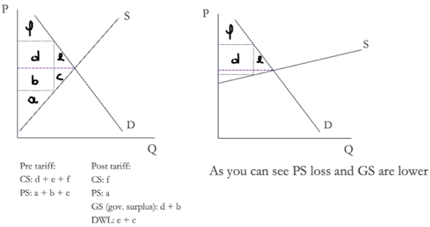  Small countries have no bargaining power on foreing markets  Before, for small countries, independent of our demand (how much we import) prices of the world won’t move: We pay Pw + T, they receive Pw. The import price is not influenced by the amount imported.  Basically foreigners supply is perfectly inelastic (horizontal) bc our demand is irrelevant  => full economic burden of a tax is on consumers, see graph for proof  Now, we have to consider the equilibrium in the foreign market!!! Our demand affects their equilibirium!  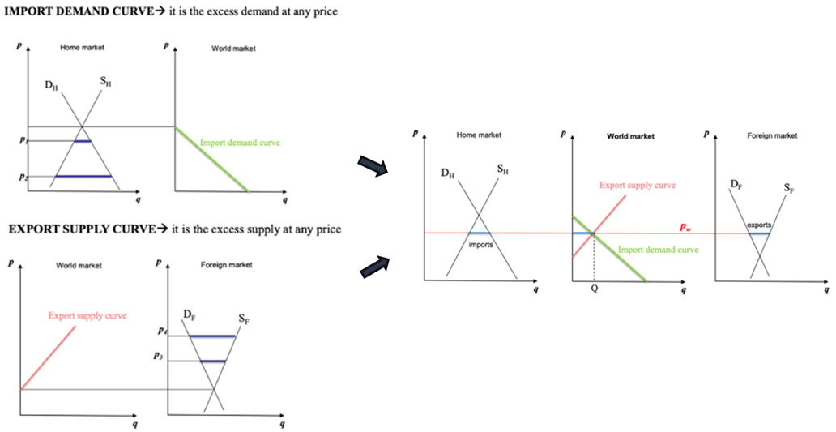  TARIFF  Home (Eu) imposes a tariff => Home imports less => Foreign (Es) will have overproduction in its market  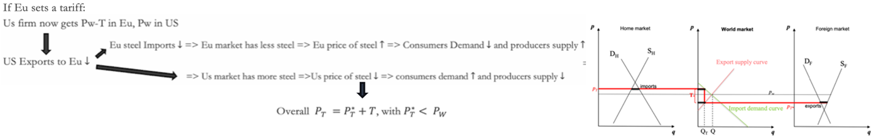  In Eu at the end P increases less than Pw + T (The bigger is eu the less it increases!). Basically Europeans now can get lower pre tariff imports prices! = They experience a Terms of tarde improvement (*terms of trade: price of exports – terms of imports)!!!  Welfare effect, Home:  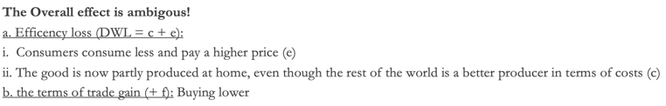  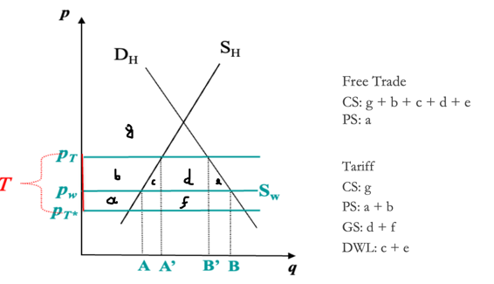  => Being a large country allows you to have bargaining power. It makes the threat of raising tariffs credible, as small tariff ma actually improve your welfare, while for small countries this si always false!!!  Tariffs, Quotas Numerical example  - $Q_{H}^{D}$: 20-P  - $Q_{H}^{S}$: P – 2  - $S_{W}$ = 4 <= Small country assumption!  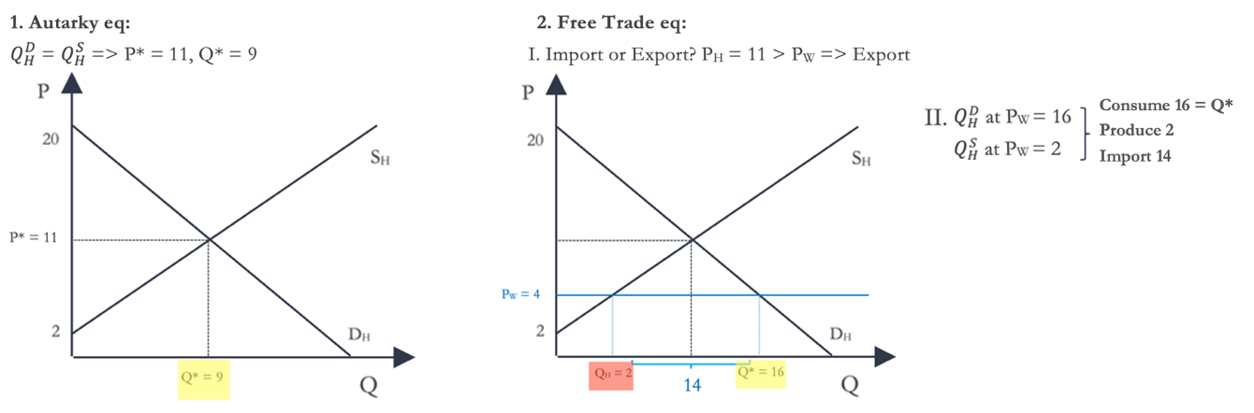  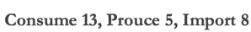  3. Tariff = 3 => Pw + T = 7  $Q_{H}^{D}$ at P_{T} = 13  $Q_{H}^{S}$ at P_{T} = 5  4. Prohibitive tariff: T st P_{W} + T = P_{H} => T* = 7 => P_{T} = 11  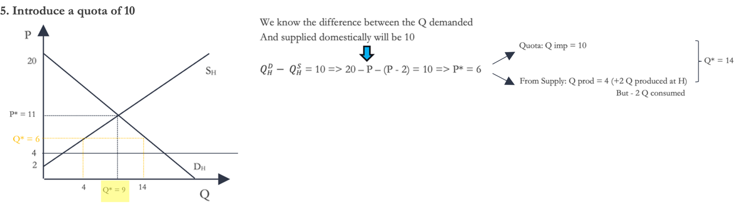  6. Quota to recreate Autarky? Q = 0  7. Quota such that P* = P_{H} ?  $Q_{H}^{D}$ - $Q_{H}^{S}$ = 20 – P - ( P - 2) with P = P_{T} => Ex. P_{T} = 7 (as before) => Quota = 20 – 7 – (7 - 2) = 8  In fact with 8 = 20 – P – (P - 2) => P_{T} = 7 and:  